Assignment 5: Developing a Class-Based Ride Sharing System

Prashanna Acharya
Advanced Programming Languages (MSCS-632-A01)
University of the Cumberlands
Dr. Jay Thom

Github Link: https://github.com/prashcodes10/MSCS632_Assignment5

Ride Sharing System in C++ and Smalltalk
This project implements a class-based Ride Sharing System using two object-oriented programming languages: C++ and Smalltalk. The system includes rides, specific ride types, drivers, and riders. The main purpose of the project is to demonstrate three major object-oriented programming principles: encapsulation, inheritance, and polymorphism. Both versions of the program use a base Ride class, two ride subclasses, and separate Driver and Rider classes to organize the system.
Encapsulation is used by grouping related data and behavior inside classes. In the C++ version, the Driver and Rider classes keep their ride lists private using the private access modifier. For example, assignedRides in the Driver class and requestedRides in the Rider class cannot be directly accessed outside the class. Instead, rides are added through methods such as addRide() and requestRide(). This protects the internal data and ensures that ride information is handled through controlled methods. In the Smalltalk version, instance variables such as assignedRides and requestedRides are also stored inside their classes. Although Smalltalk does not use public and private keywords in the same way as C++, the data is still accessed through class methods, which supports encapsulation.
Inheritance is shown through the relationship between the Ride class and the ride subclasses. The Ride class contains common attributes such as rideID, pickupLocation, dropoffLocation, and distance. The StandardRide and PremiumRide classes inherit from Ride and reuse its shared data and behavior. This avoids repeating the same code in multiple places. Each subclass represents a different ride type and provides its own fare calculation. In C++, inheritance is written using class StandardRide : public Ride and class PremiumRide : public Ride. In Smalltalk, inheritance is created by defining StandardRide and PremiumRide as subclasses of Ride.
Polymorphism is demonstrated by storing different ride objects in one collection and calling the same method on each object. In the C++ version, a vector of Ride pointers stores StandardRide and PremiumRide objects. When calculateFare() or rideDetails() is called, the correct version of the method is selected based on the actual object type. This works because the base class methods are declared as virtual and the subclass methods override them. In the Smalltalk version, polymorphism happens naturally because objects respond to messages. The program sends the rideDetails message to each ride in an OrderedCollection, and each object responds according to its own class.
The system also includes basic driver and rider functionality. The Driver class stores information such as driverID, name, rating, and completed rides. The Rider class stores riderID, name, and requested ride history. These classes make the system more realistic because they show how ride objects can be connected to users in the application. Overall, both implementations successfully demonstrate object-oriented design. C++ provides stricter control through access modifiers and virtual functions, while Smalltalk uses a simpler message-based style that clearly shows how objects communicate.

Screenshots
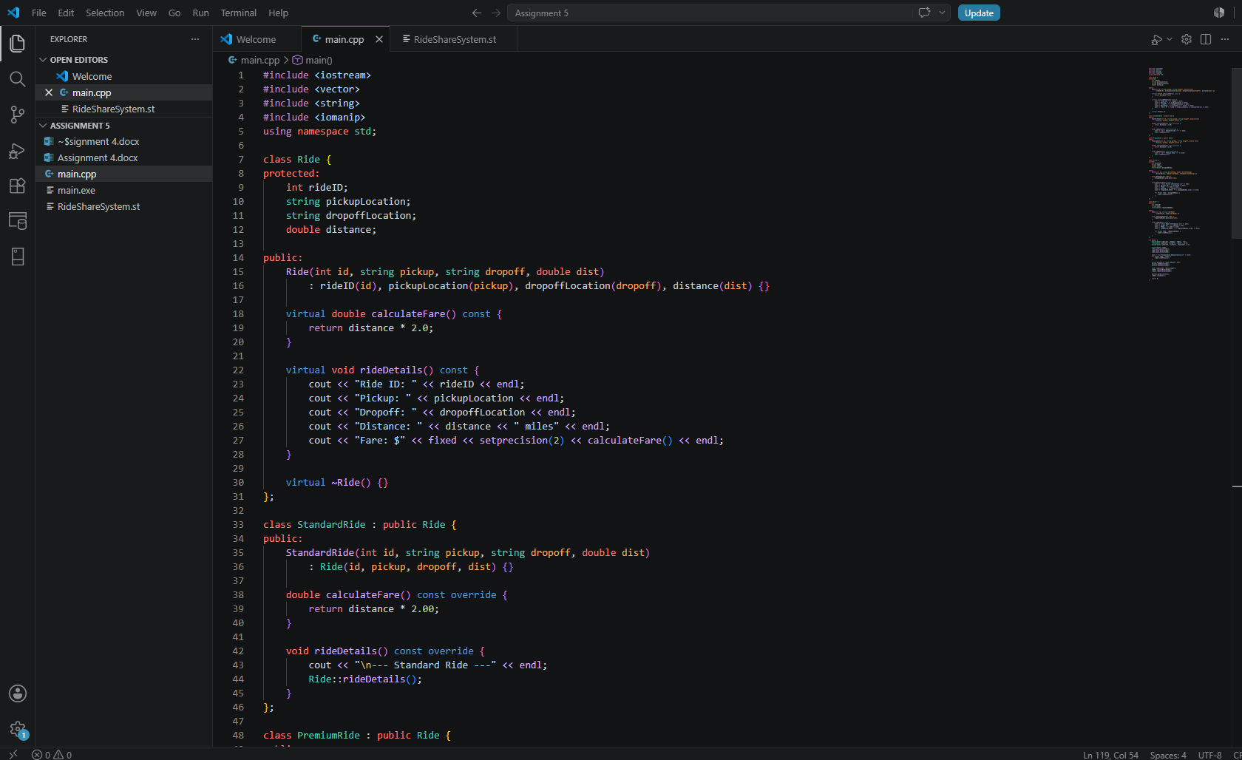
Figure 1: C++ code screenshot


Figure 2: C++ sample output screenshot
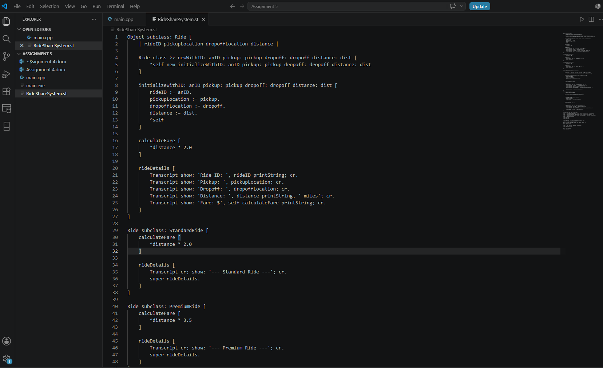
Figure 3: Smalltalk code screenshot

Figure 4: Smalltalk sample output screenshot

Reference
Sebesta, R. W. (2019). Concepts of programming languages (12th ed.). Pearson.

